**Zombie Process**

**Approach - 2**

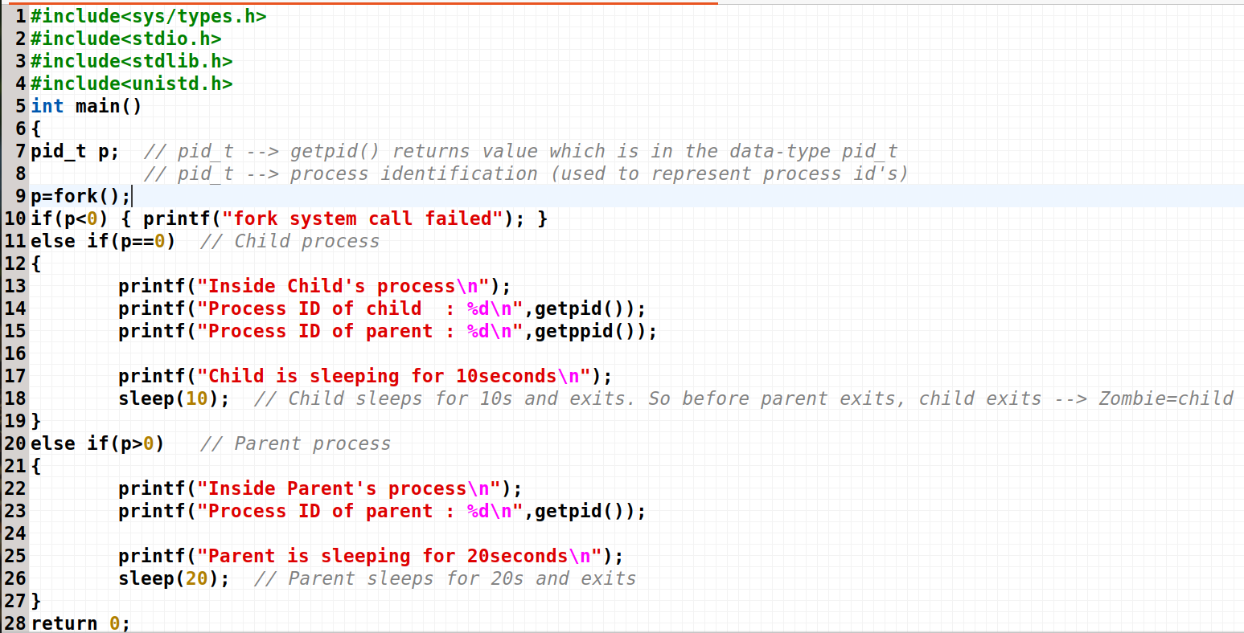

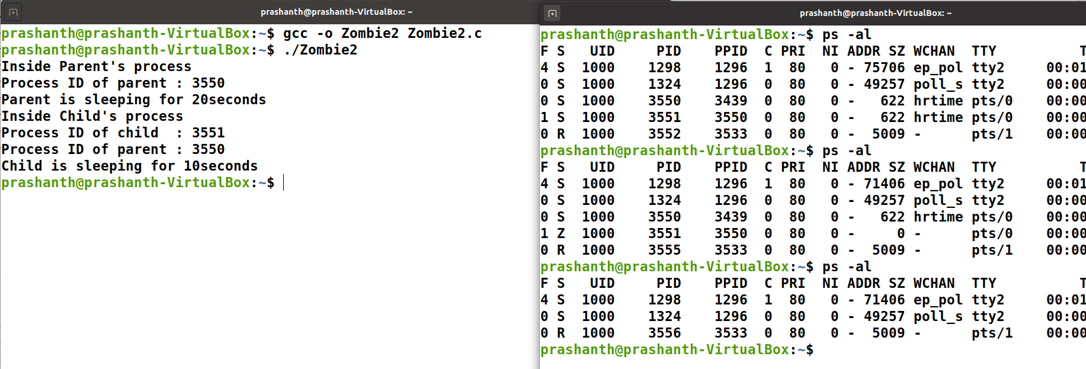

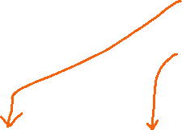

Parent and Child are executing. Parent 🡪 executing and child 🡪 Zombie

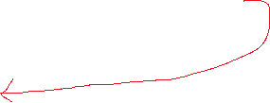

Both the process finishes its execution

**Approach-2**

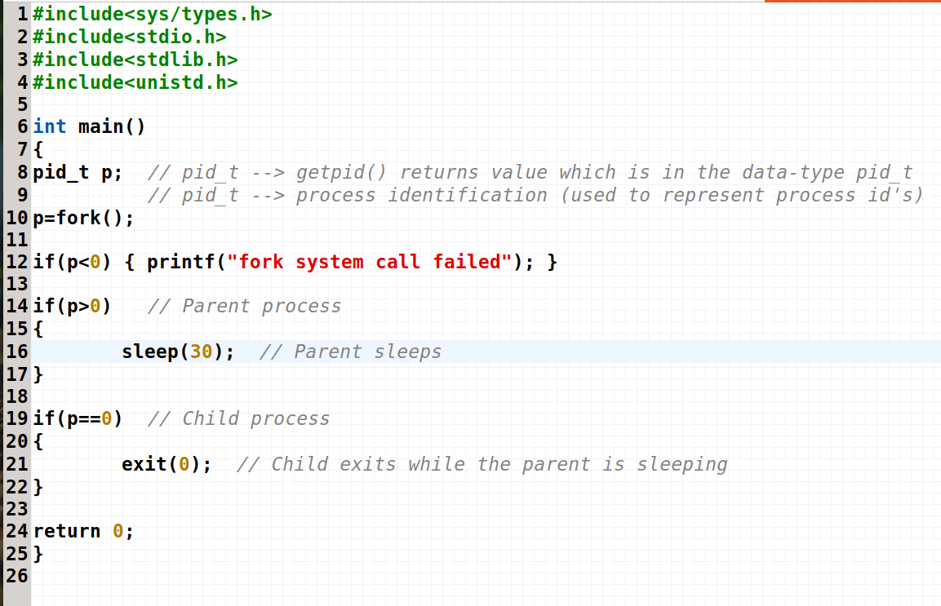

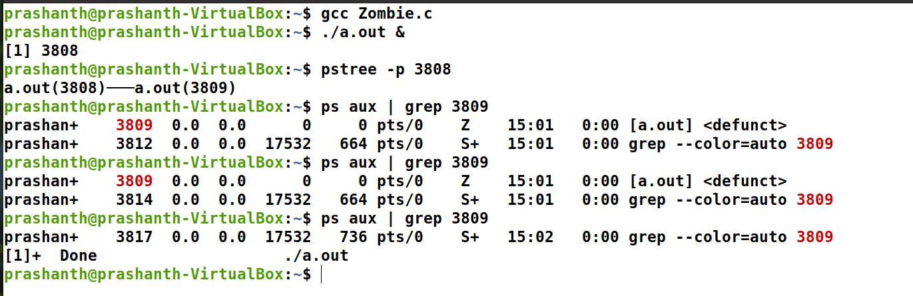



Parent and child successfully executed and gone out